**DAY 2 PLANNING THE TECHNICAL FOUNDATION**

**Day 2 -- PLANNING THE TECHNICAL FOUNDATION**

**What was the problems of marketplace? What is the solution for marketplace?**

1. **Flexibility:** Rent furniture for temporary use instead of buying.
2. **Lower Costs:** Rent furniture for a fraction of the purchase price.
3. **Access to Quality:** Rent high-quality furniture without long-term commitment.
4. **Easy Delivery & Pickup:** Flexible delivery and return options.
5. **Trusted Rentals:** Centralized, reliable platform for renting or buying.
6. **Simplified Returns:** Clear return policies and easy furniture pickup.
7. **Short-Term Housing Needs:** Furnish temporary spaces without a large upfront cost.
8. **More Rental Variety:** Offer a wide range of rental furniture options.
9. **Sustainability:** Provide eco-friendly rental furniture options.
10. **Trust in Quality:** Detailed product info and reviews to ensure quality.
11. **Simplified Shopping:** Clear options for both renting and buying, reducing market confusion.
12. **No Flexibility:** Customers need temporary furniture but can only buy.
13. **High Costs:** Furniture is expensive for short-term use.
14. **Limited Quality Rentals:** Rental furniture options may not be good quality.
15. **Complicated Delivery & Returns:** Renting furniture can be hard to manage logistically.
16. **Untrustworthy Rentals:** Not enough reliable rental services.
17. **Complex Returns:** Rental return processes can be difficult.
18. **Short-Term Housing Solutions:** People moving temporarily struggle to find affordable furniture.
19. **Limited Rental Variety:** Few platforms offer diverse rental furniture options.
20. **Lack of Eco-Friendly Choices:** Limited availability of sustainable furniture.
21. **Trust Issues:** Customers worry about the quality and durability of rental furniture.
22. **Market Confusion:** Customers get confused with platforms offering only rentals or purchases.

### Target Audience: Unique Value Proposition:

1. Flexible Options
2. Affordable Pricing
3. Sustainability
4. Convenience
5. Wide Selection
6. Trust and Quality
7. Young Professionals 2. Students
8. Travelers/Expats 4. Small Families
9. Eco-Conscious Consumers
10. Budget-Conscious Shoppers
11. Interior Designers/Real Estate Agents
12. Homeowners for Seasonal Updates
13. Online Shoppers

**Key Features:**

1. **Rent or Buy Options:** Allow customers to choose between renting or purchasing furniture.
2. **3D Product Visualization/AR:** Let customers visualize furniture in their space with AR or 3D models.
3. **Flexible Delivery & Pickup:** Offer flexible delivery and return options for both rental and purchased items.
4. **Product Customization:** Allow customization of size, color, and material for both rented and purchased furniture.
5. **Easy Checkout Process:** Simple and secure checkout with payment options for both rental and purchase.
6. **Subscription & Rental Plans:** Provide different rental duration plans (daily, monthly, etc.).
7. **Eco-Friendly Section:** Highlight sustainable, eco-friendly furniture options.
8. **Customer Reviews & Ratings:** Allow customers to review products and share their experiences.
9. **Clear Return Policies:** Transparent return and exchange policies for both rentals and purchases.
10. **Search & Filter Options:** Advanced search and filters to help customers easily find the right furniture based on their needs (style, price, type, etc.).
11. **Live Chat Support:** Instant support for customers through live chat to answer questions and assist with decisions.
12. **Rental Agreement:** Easy-to-understand rental agreements for customers to review before renting.
13. **Wishlist & Favorites:** Let customers save their favorite items for future reference or purchase.

**Transitioning to Technical Planning**

**Technical Requirements**

* Frontend Requirements
* Sanity CMS as Backend
* Third-Party APIs

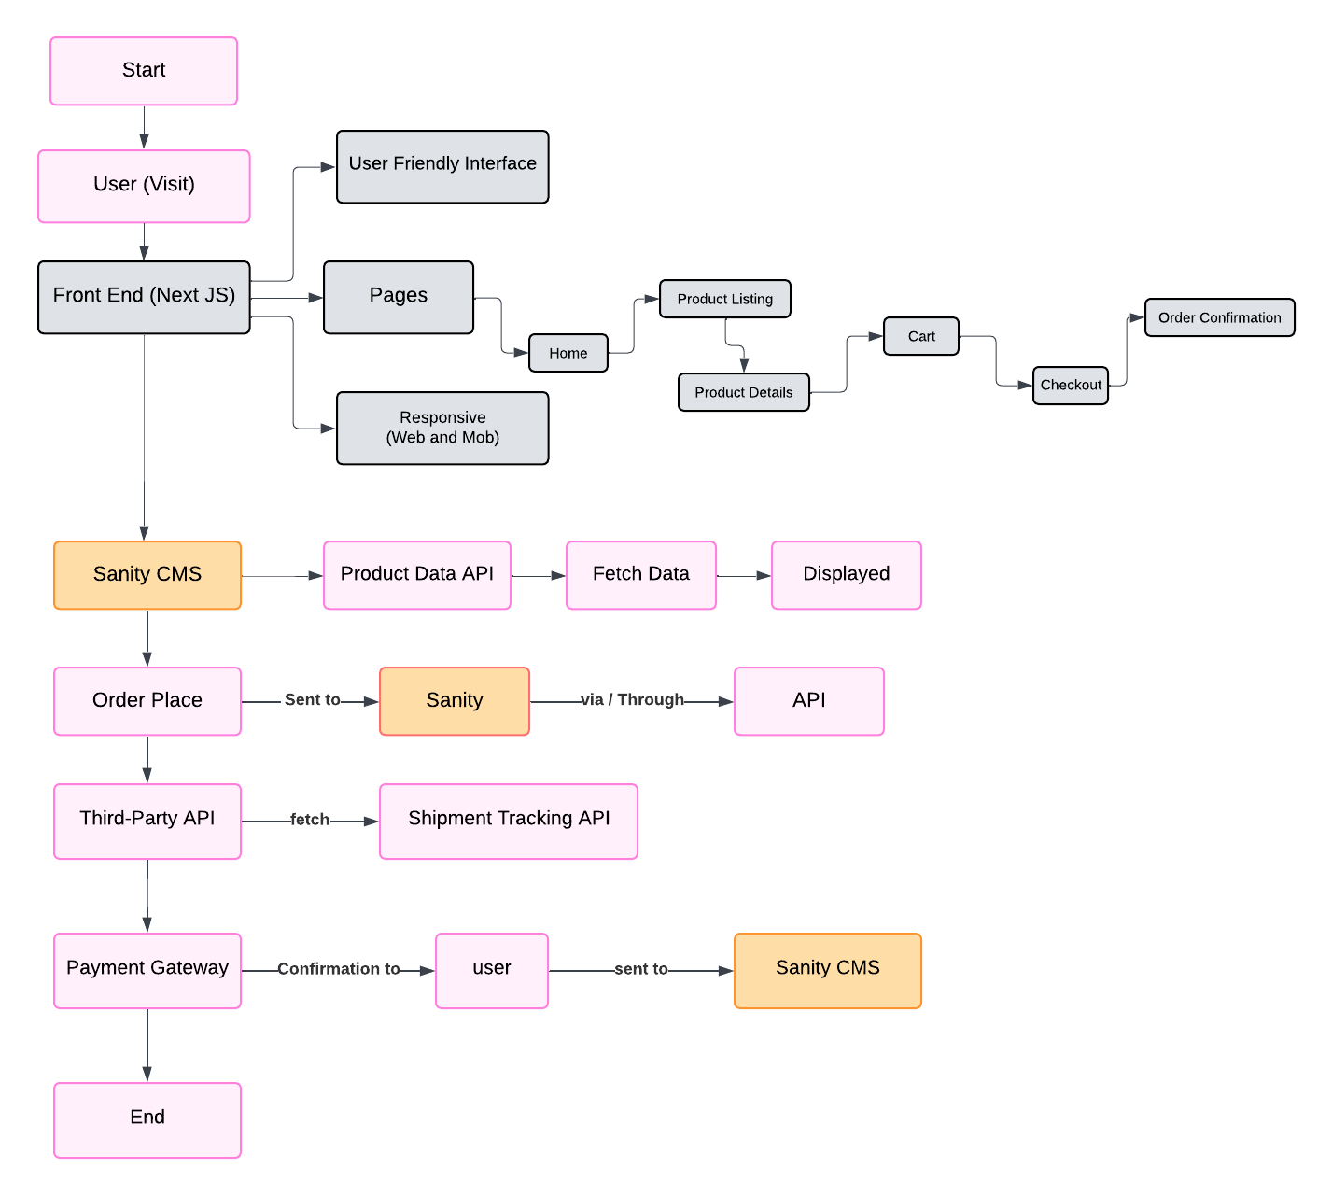

**User Registration/Login:**

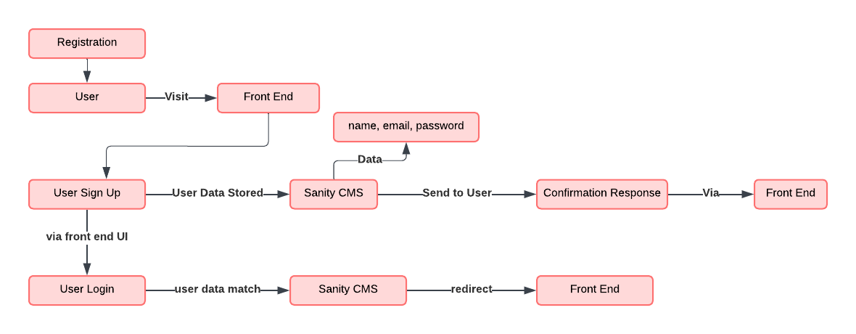

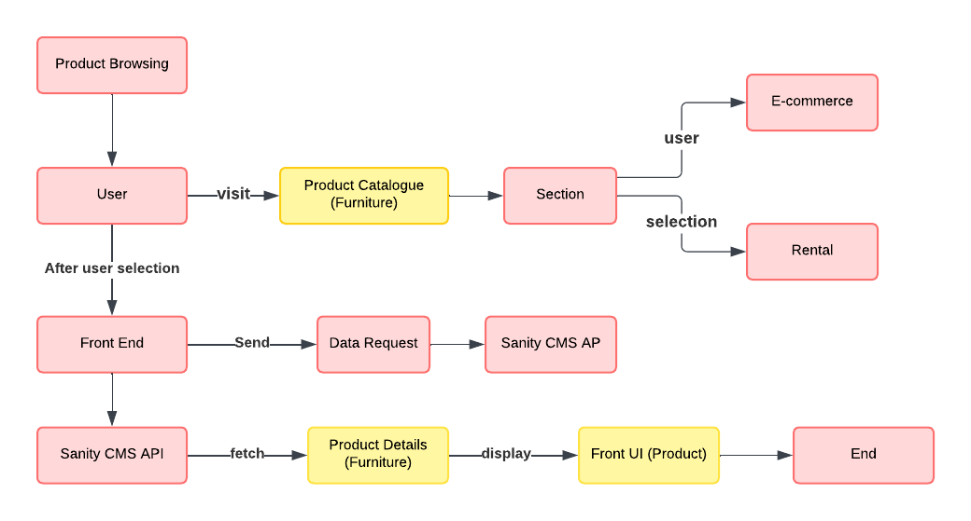**Product Browsing:**

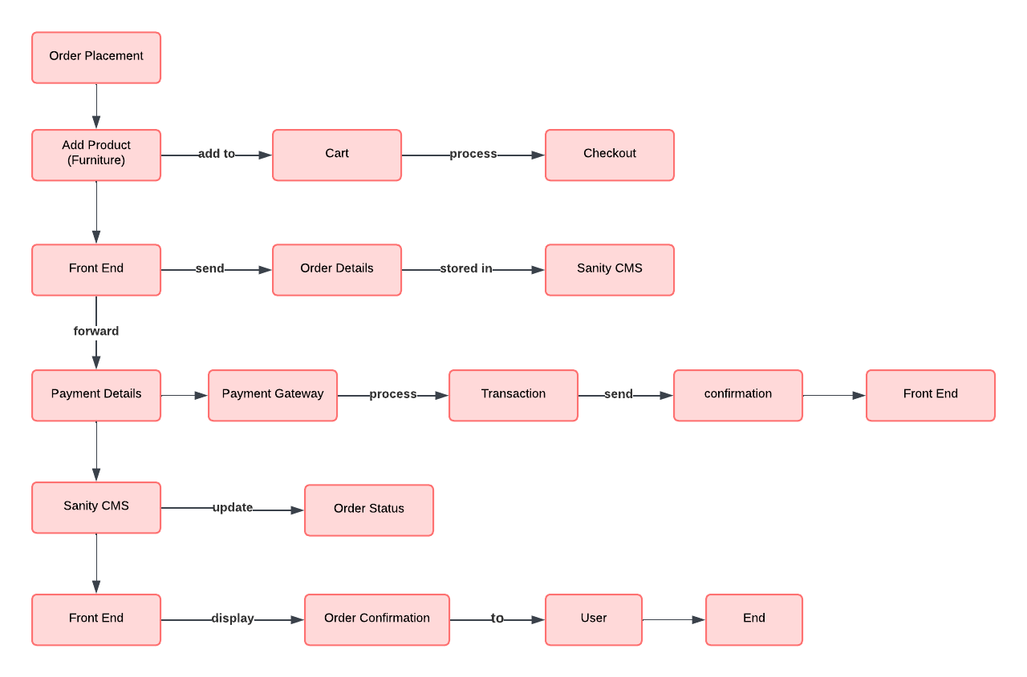**E-Commerce** **Order Placement Workflow:**

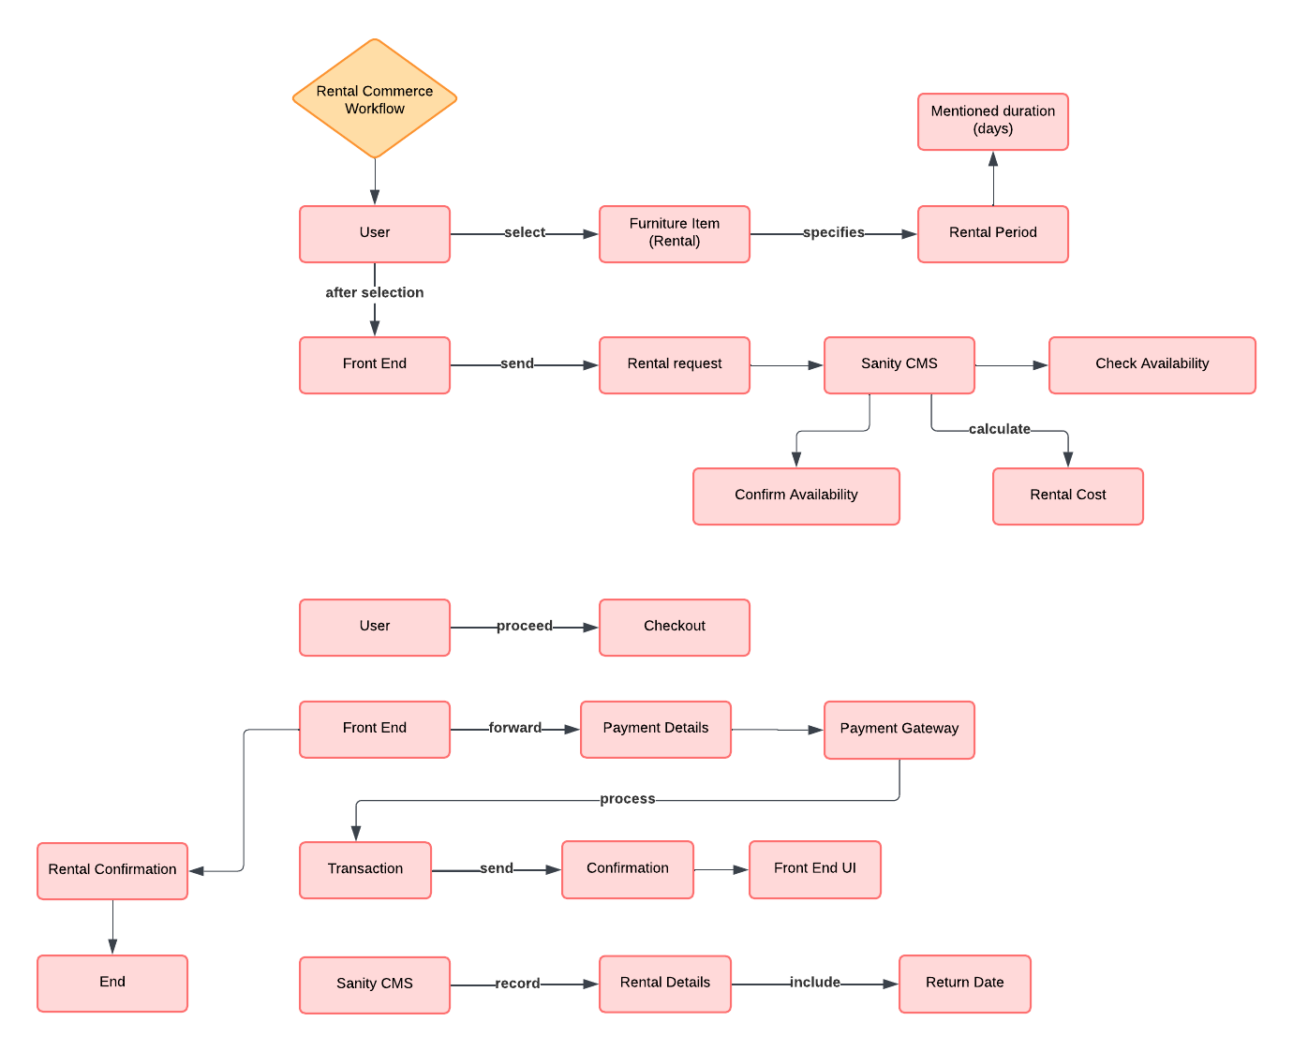**Rental Commerce Workflow:**

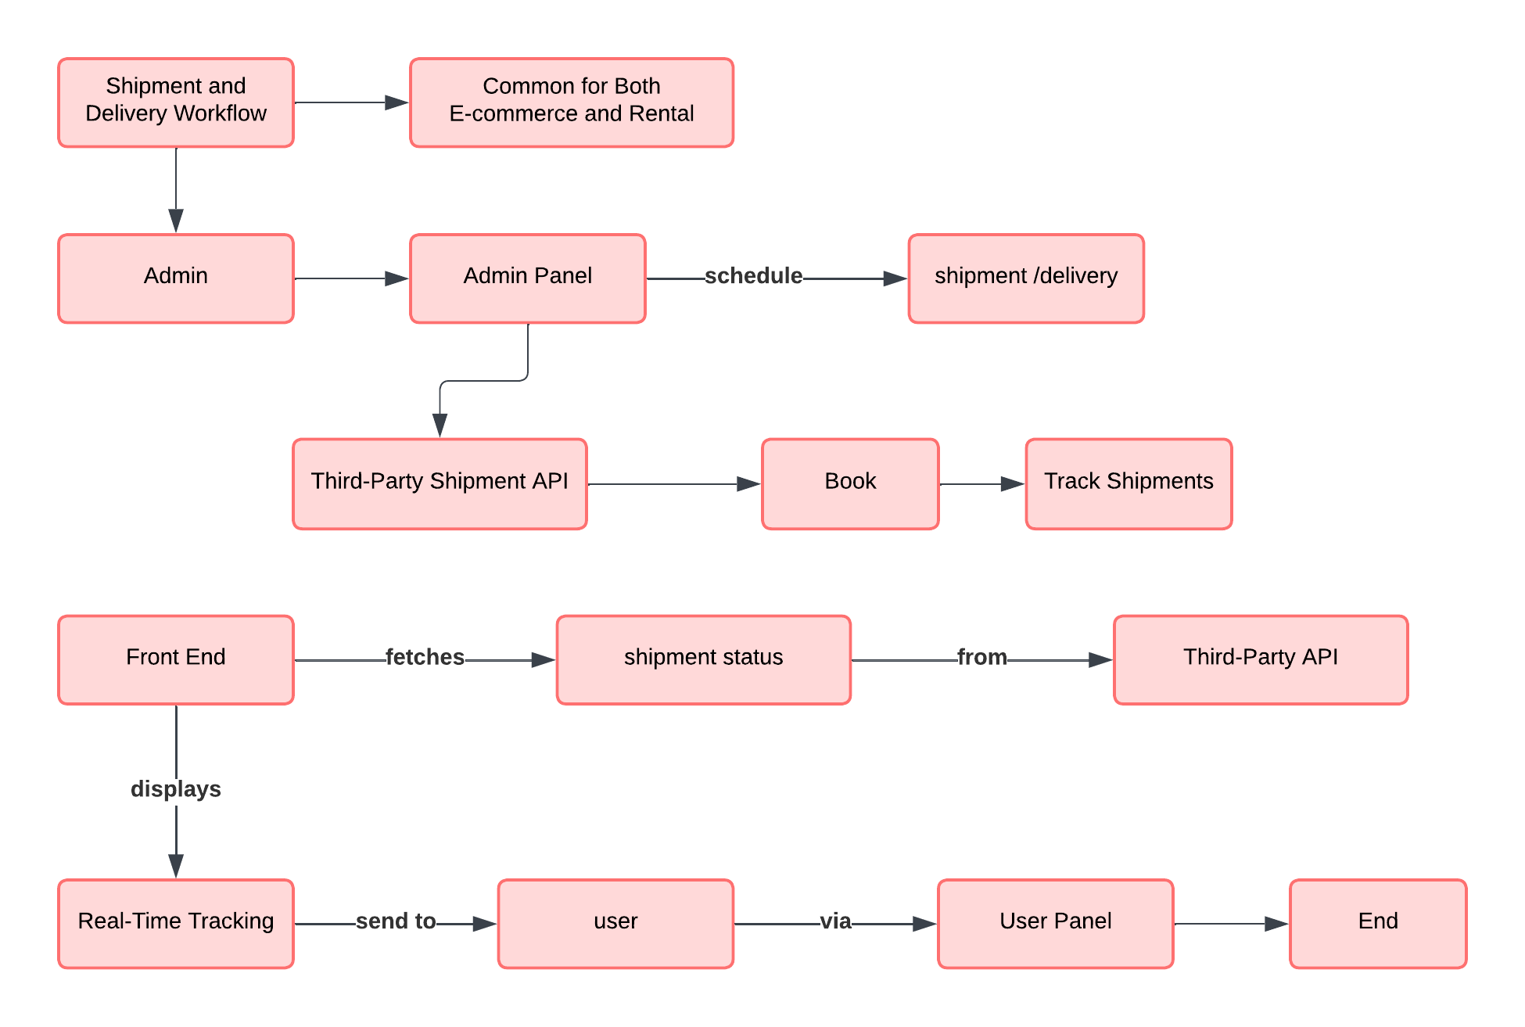**Shipment and Delivery Workflow:**

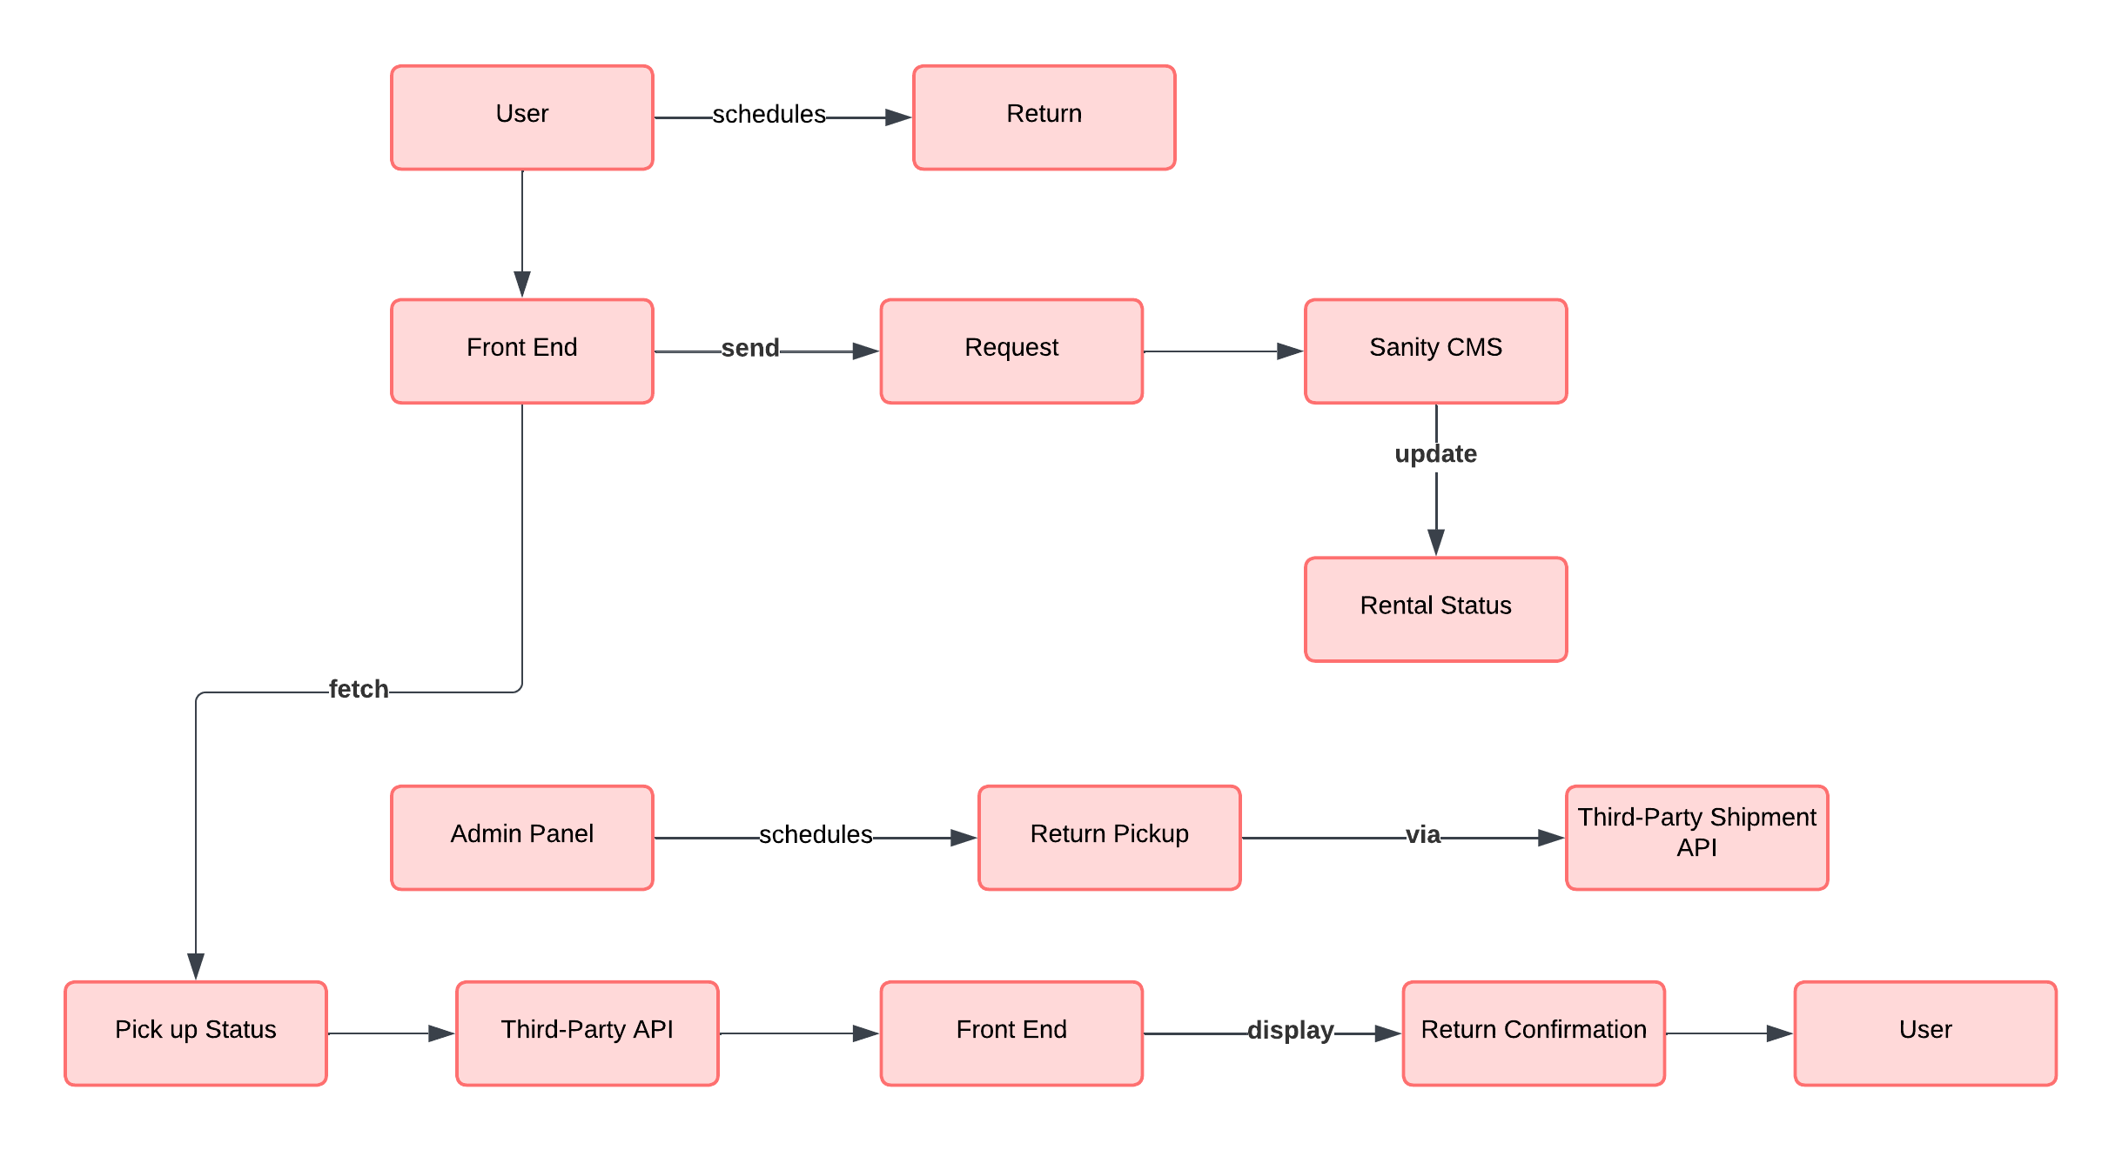**Return Workflow (For Rentals Only):**

**Admin Management Workflow:**

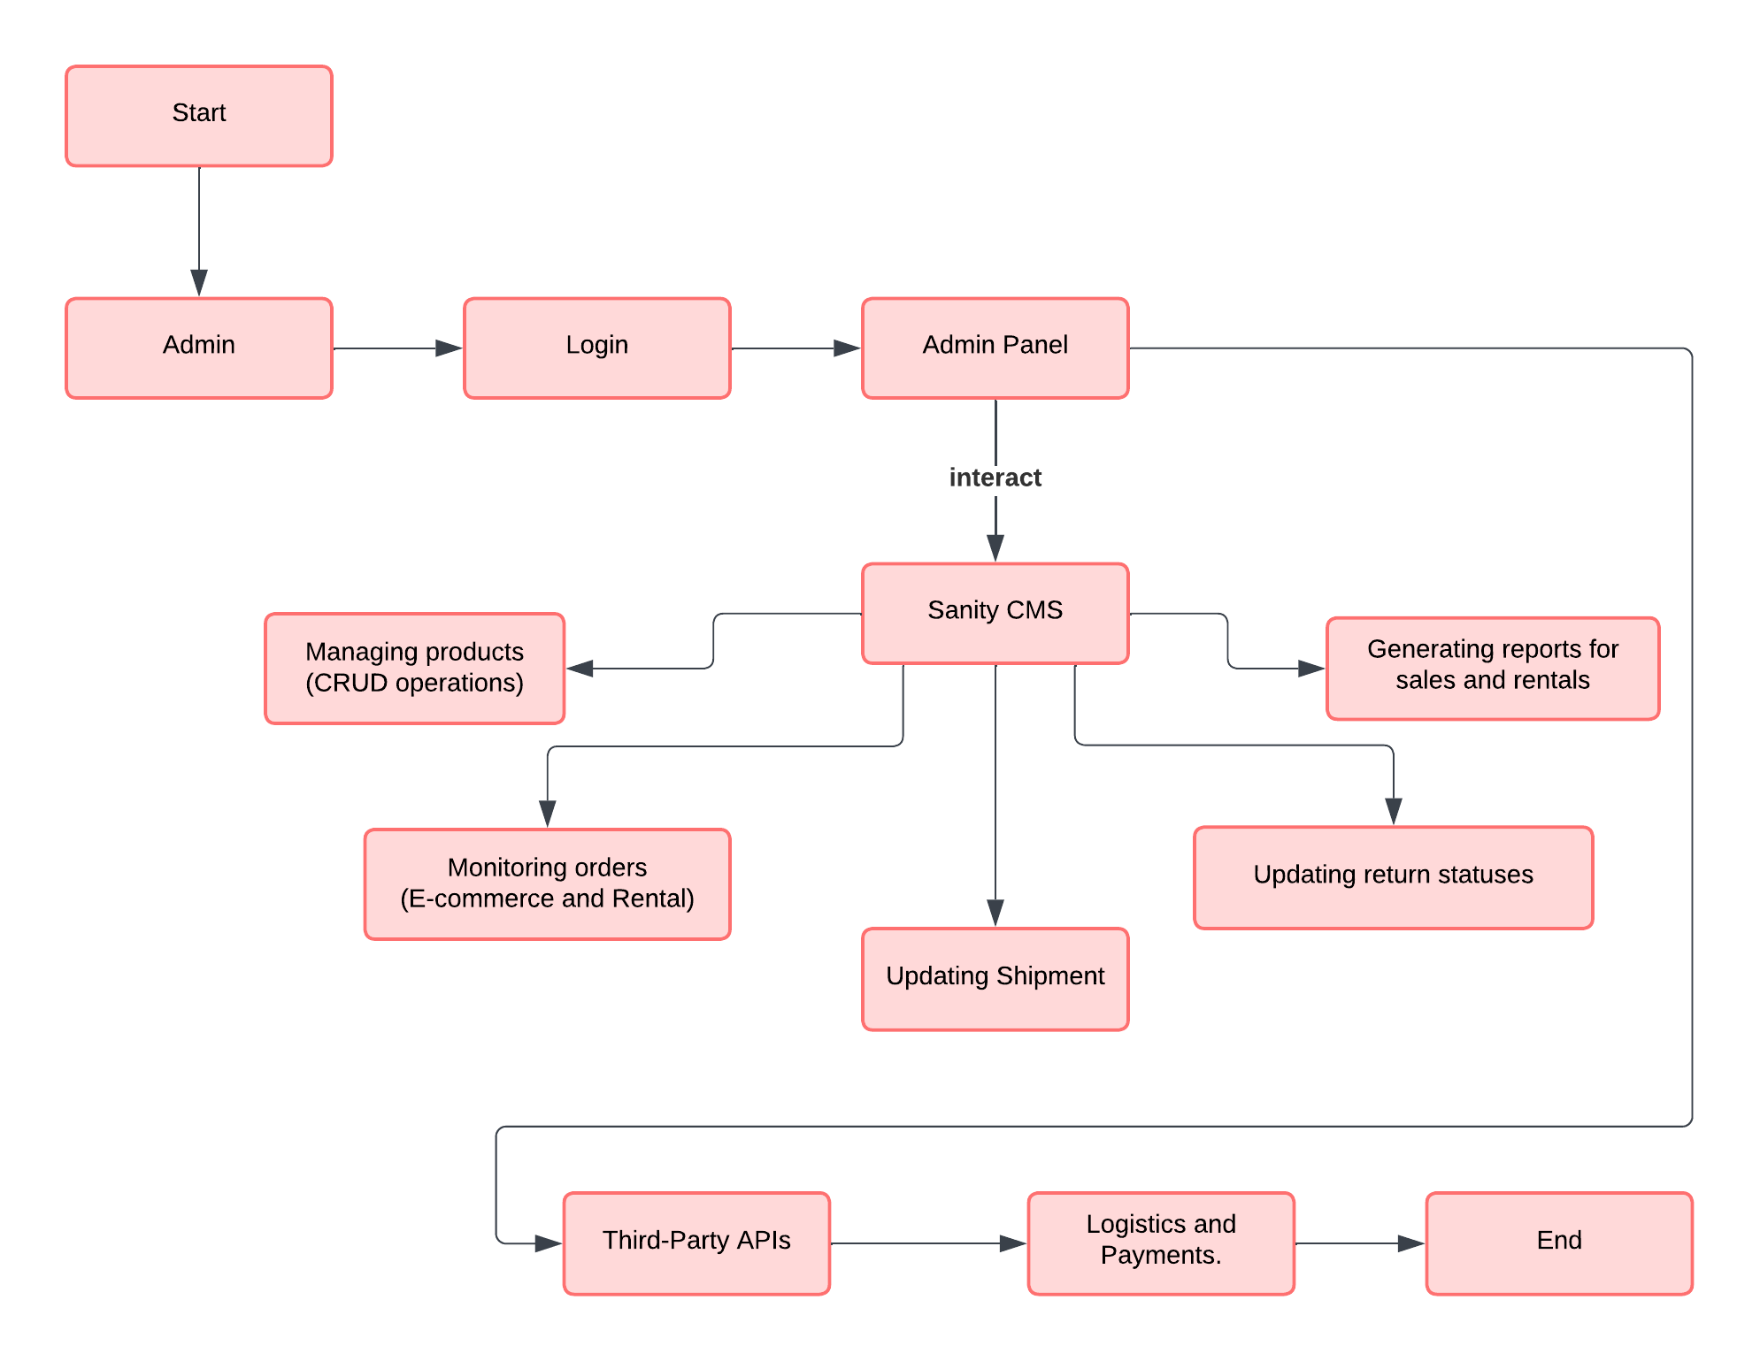

Plan API Requirements

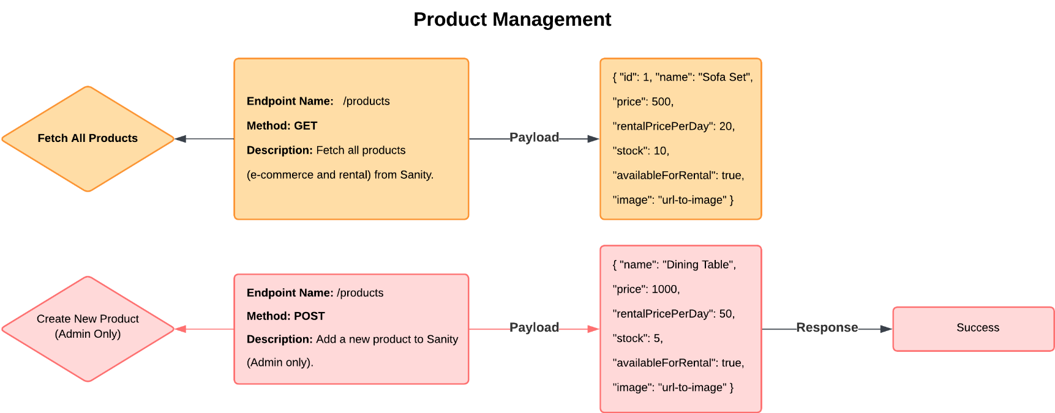**Plan API Requirements**

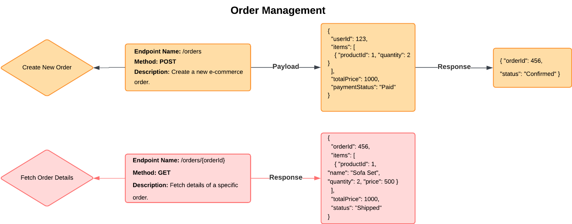

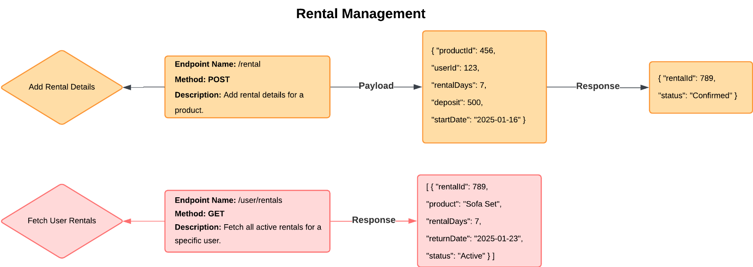

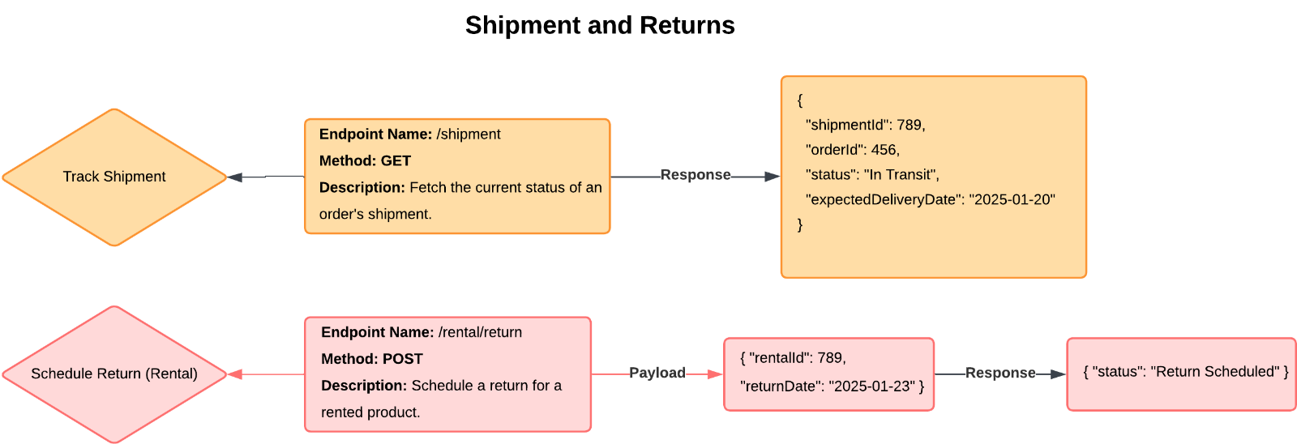

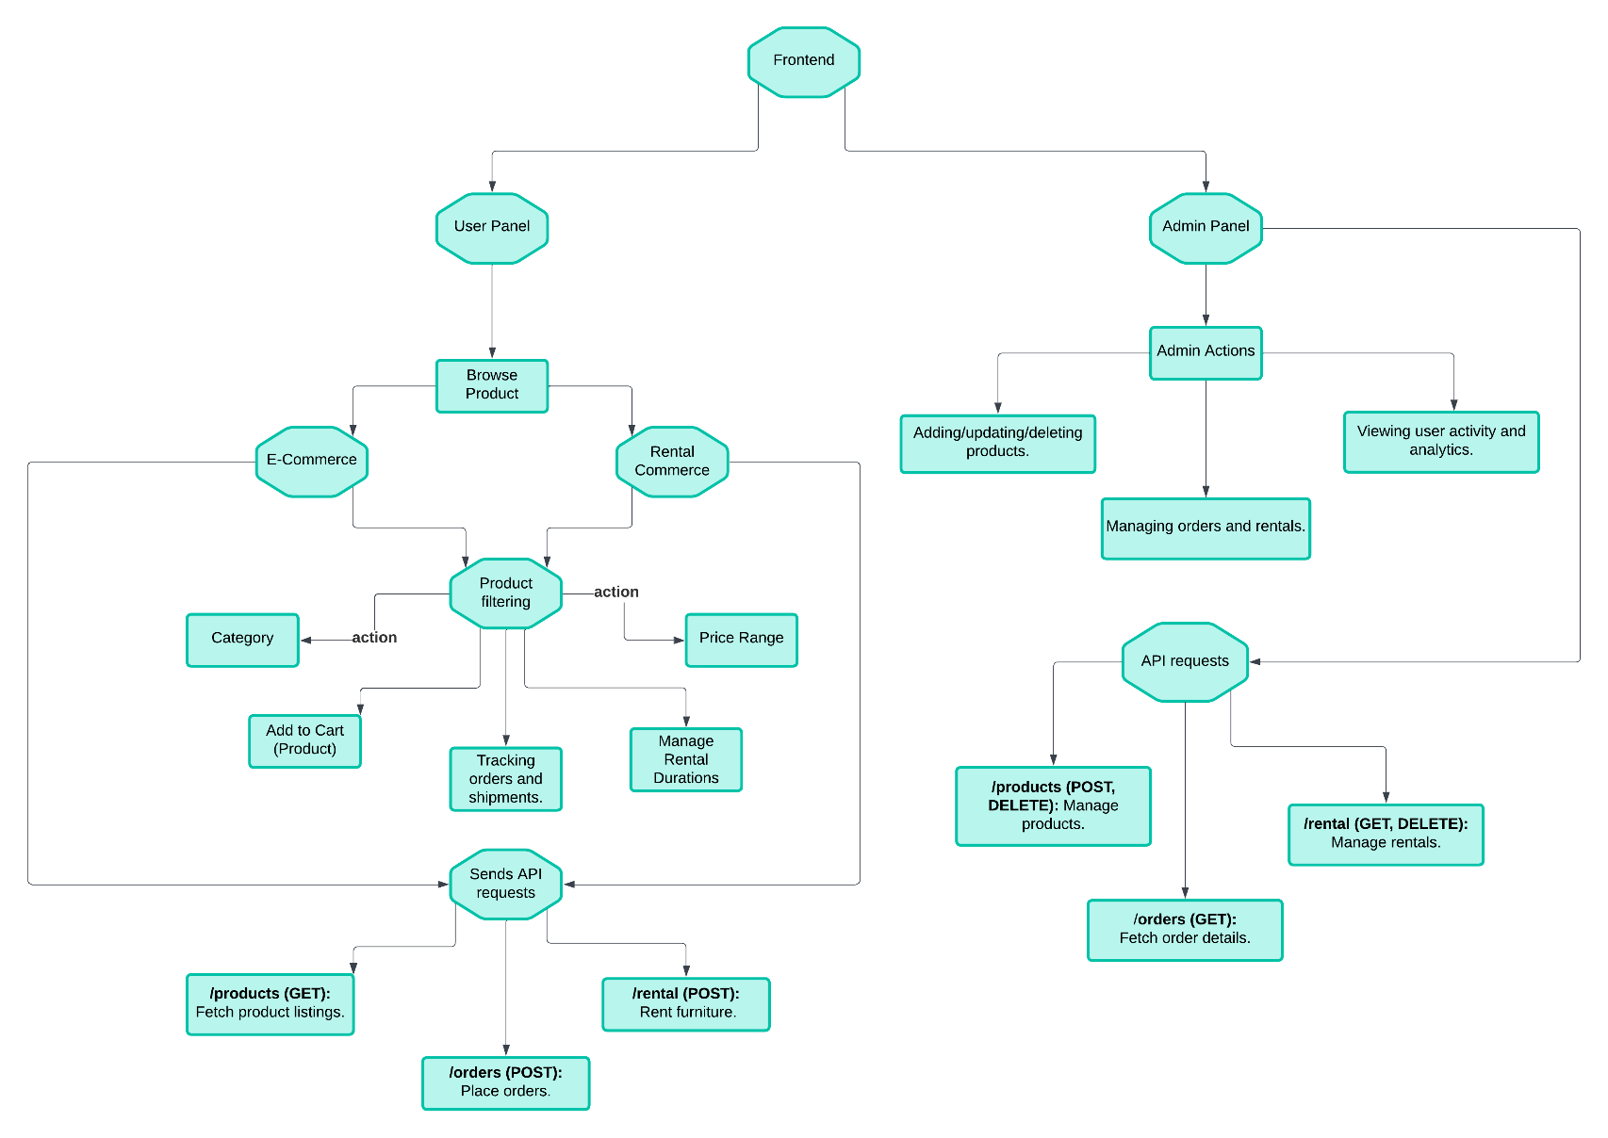**System Architecture Overview**

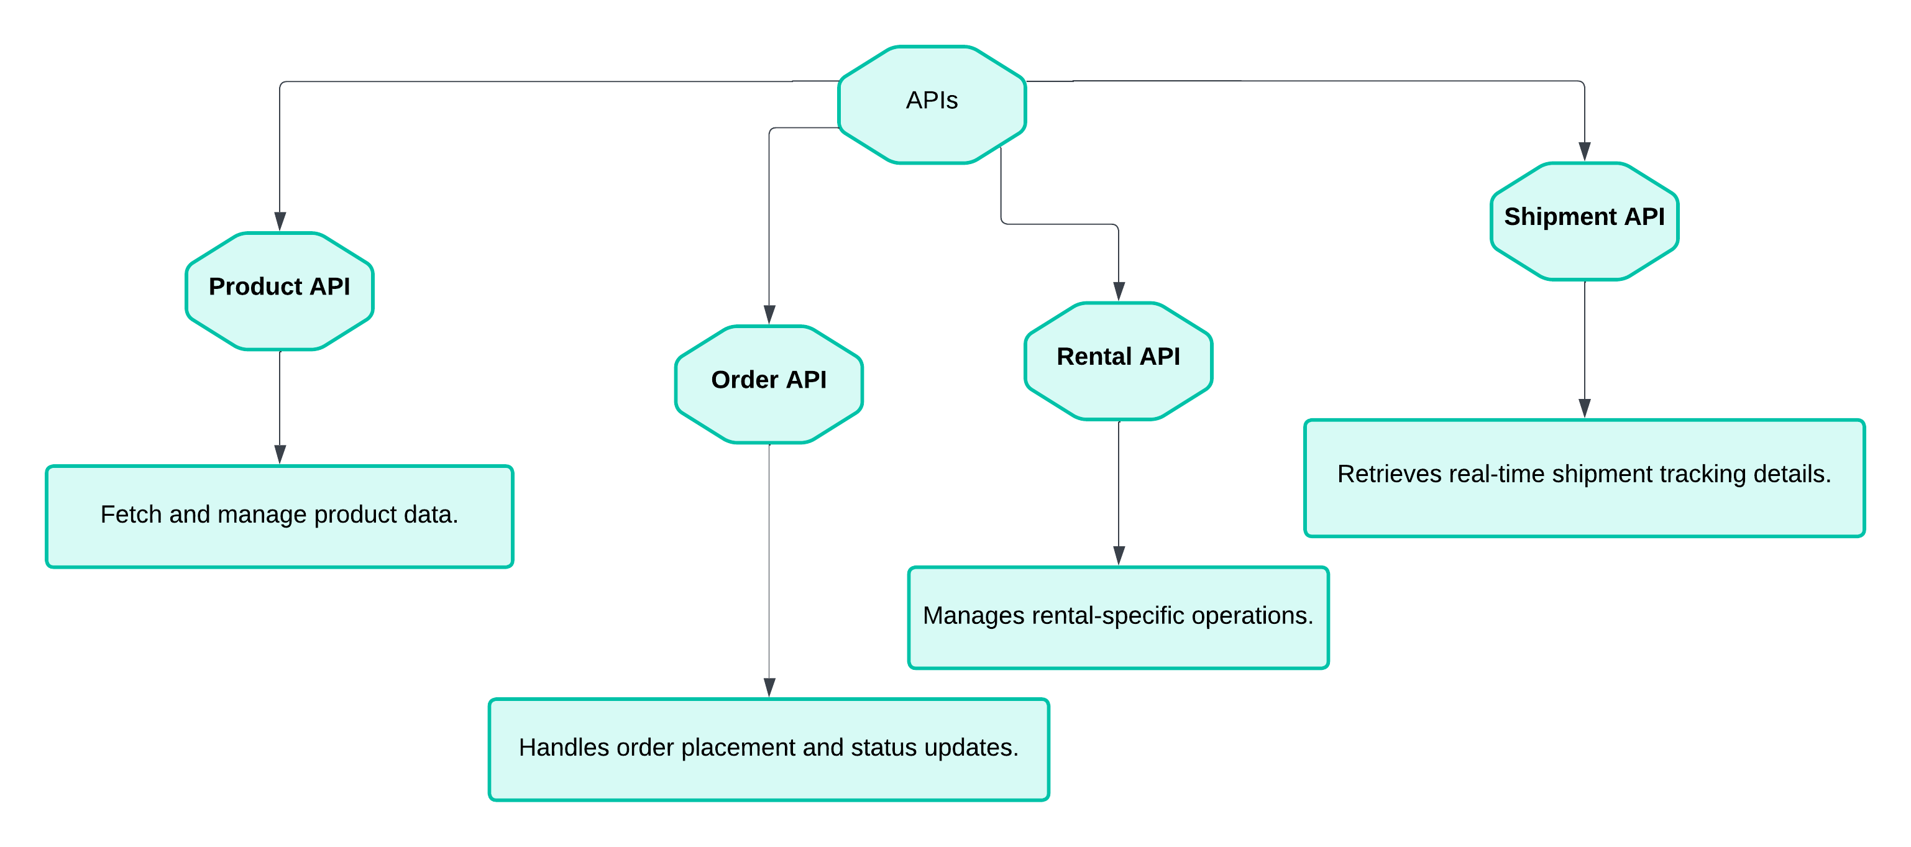

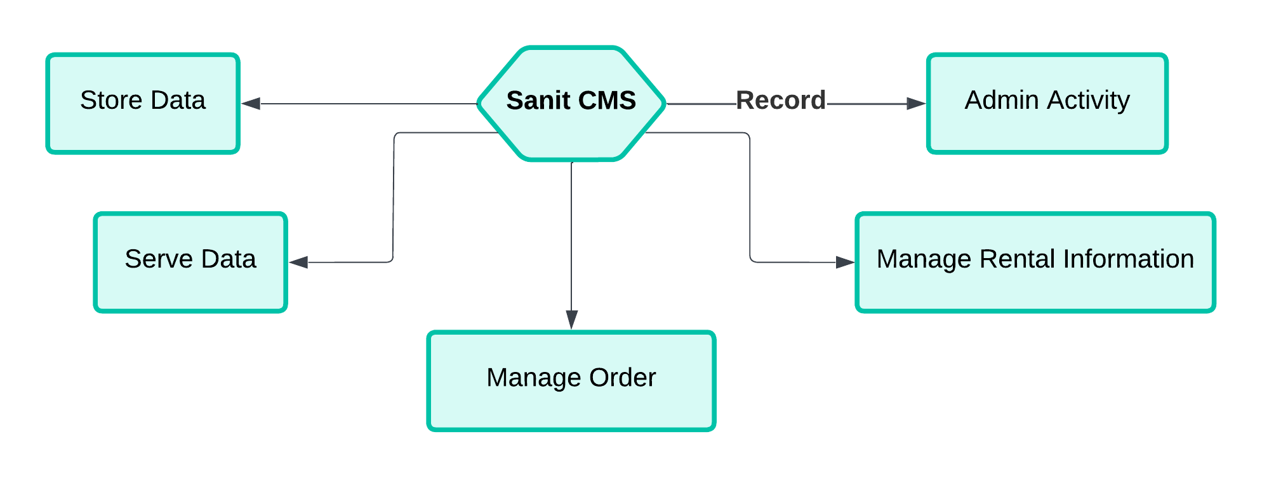

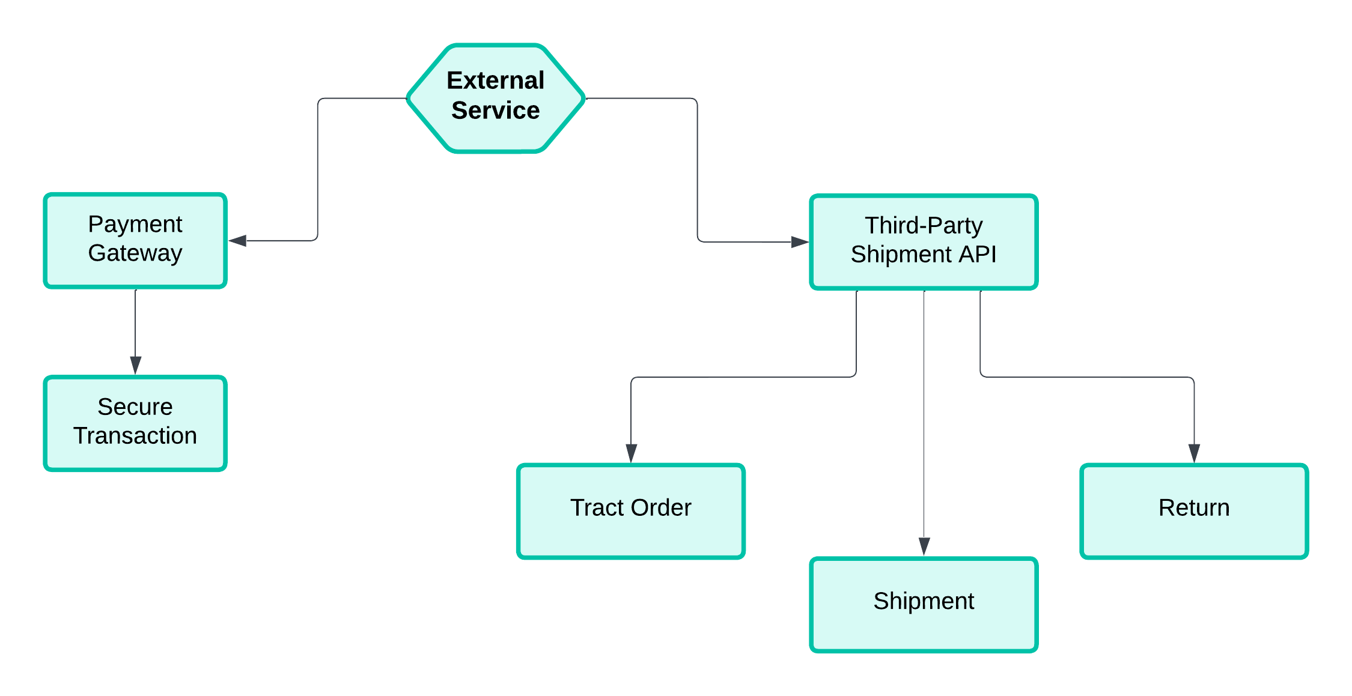

## **2. Key Workflows:**

### *****User Workflows*****

#### **Product Browsing**:

1. *User visits the website.*
2. *Frontend sends a GET request to /products API.*
3. *API fetches product data from Sanity CMS.*
4. *Data is displayed on the website for user interaction.*

#### **Placing an Order:**

1. *User adds items to cart.*
2. *User proceeds to checkout and completes payment via Payment Gateway.*
3. *Frontend sends a POST request to /orders with order details.*
4. *API stores order information in Sanity CMS.*
5. *Confirmation is displayed to the user.*

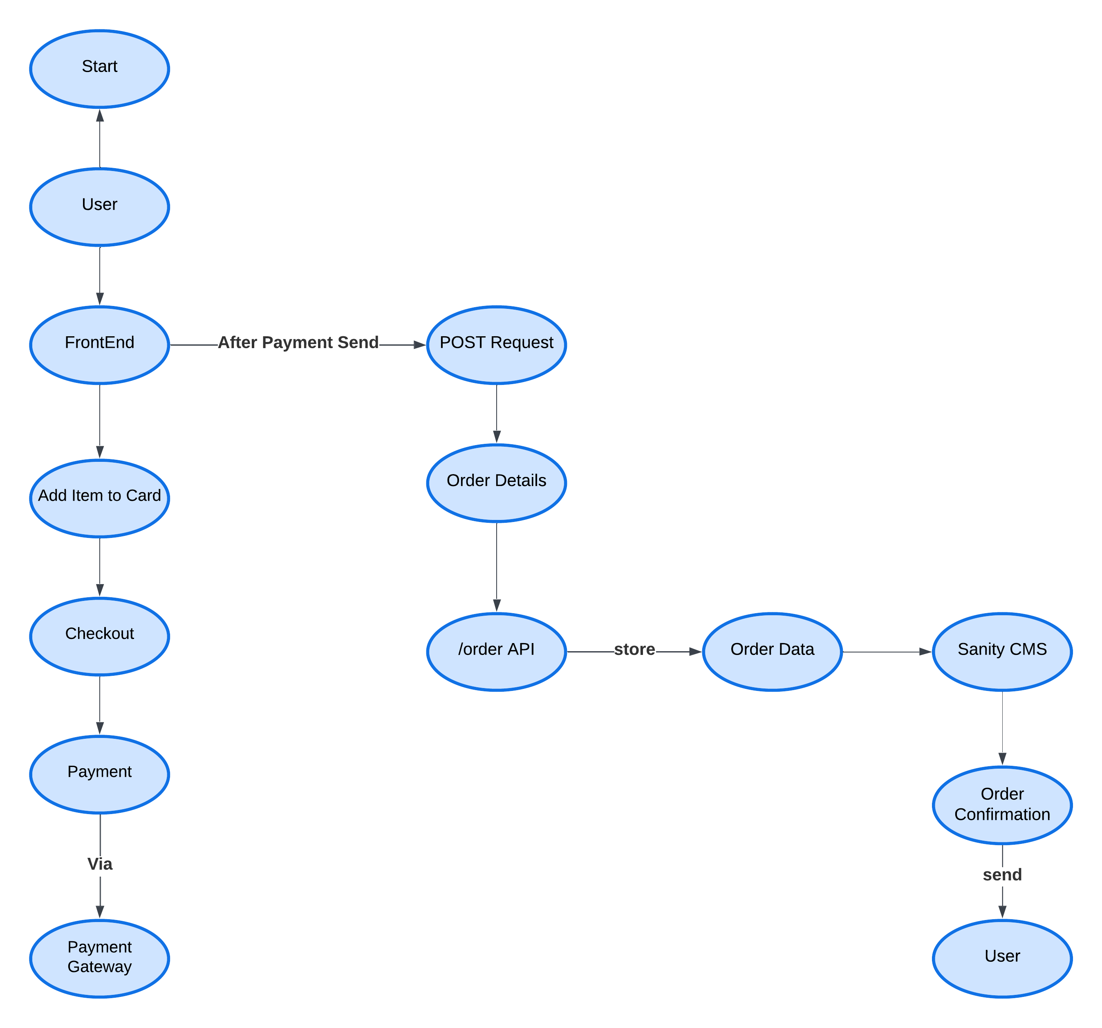

#### **Renting Furniture**:

1. *User selects a product and rental duration.*
2. *Frontend sends a POST request to /rental API.*
3. *API records rental details in Sanity CMS and deducts the deposit amount via Payment Gateway.*
4. *Rental confirmation is displayed to the user.*

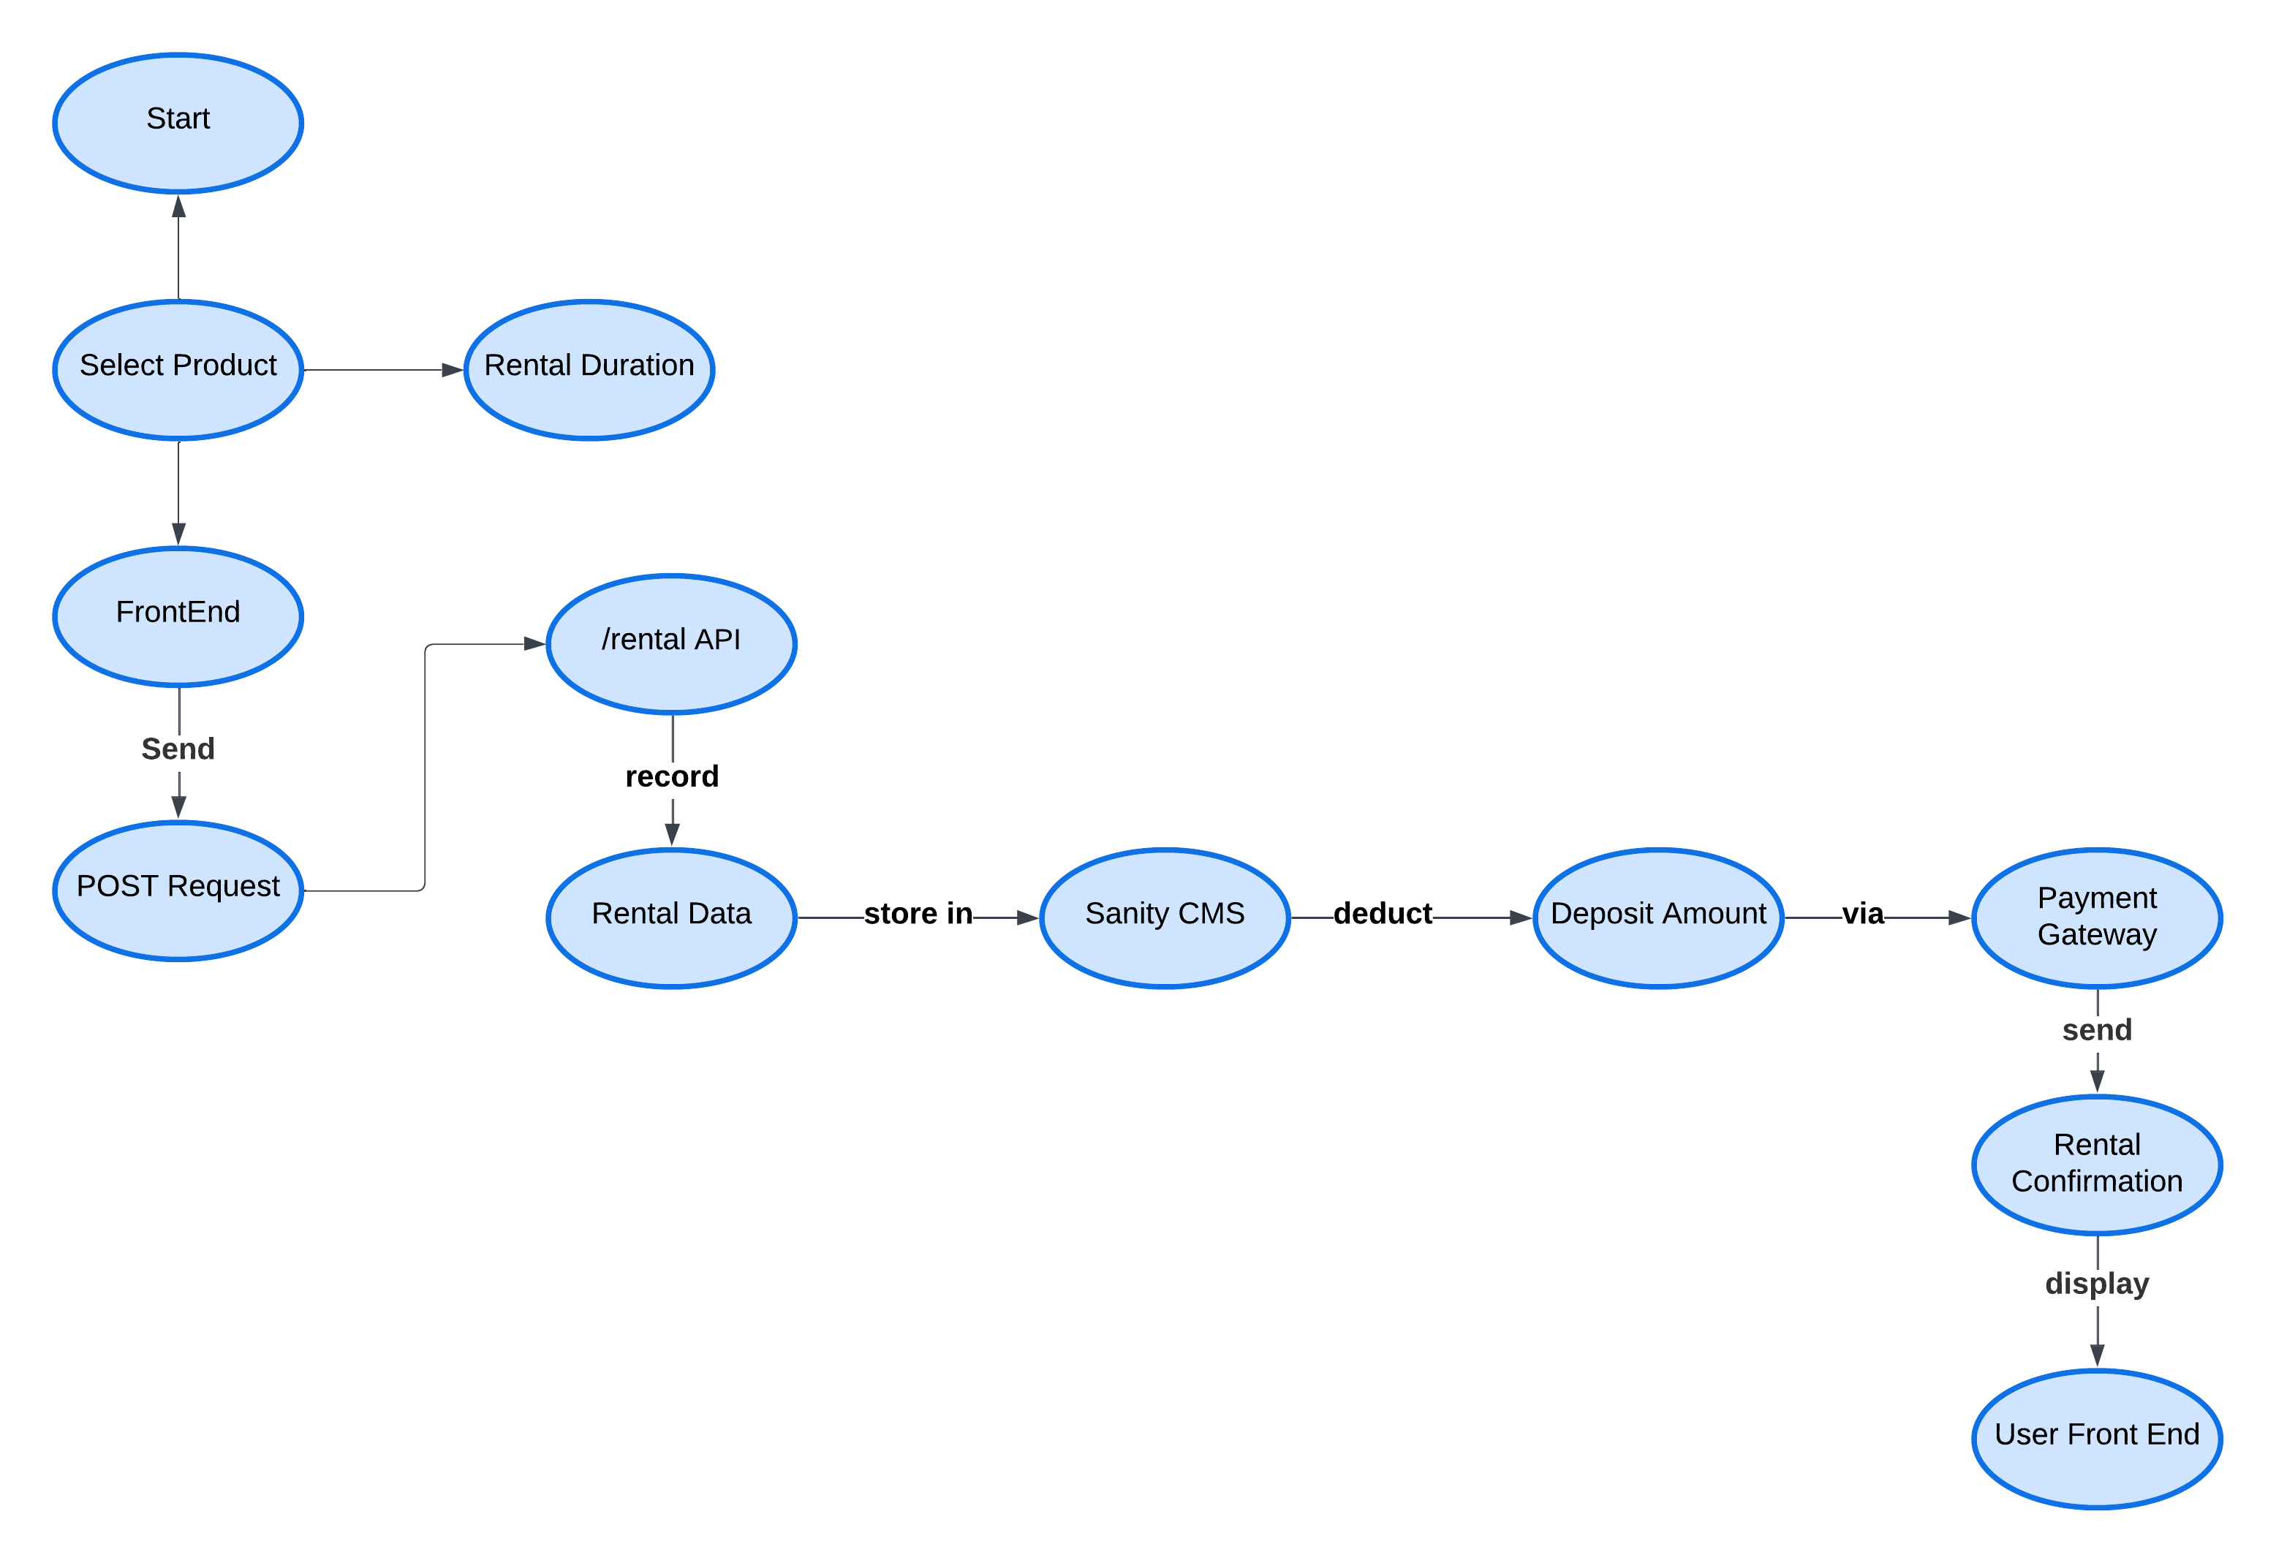

#### **Tracking Orders and Rentals**:

1. *User accesses their order/rental history.*
2. *Frontend sends GET requests to /orders or /rental.*
3. *API retrieves and displays order or rental data.*
4. *Shipment API is used to provide real-time updates for deliveries.*

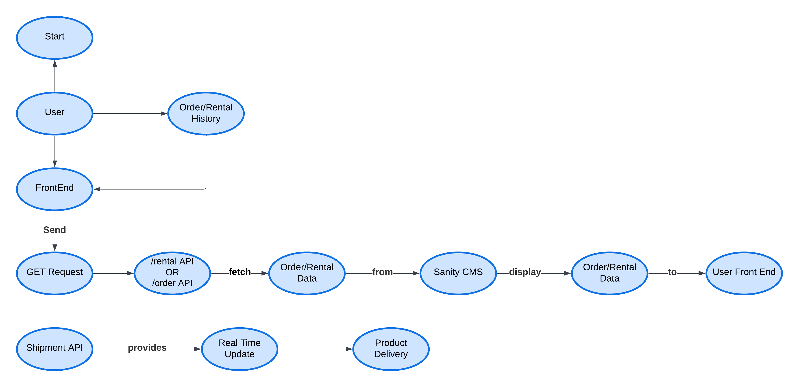

### ****Admin Workflows****

#### **Managing Products**:

1. *Admin logs into the admin panel.*
2. *Admin adds or updates product details.*
3. *Frontend sends POST/PUT requests to /products API.*
4. *API updates product data in Sanity CMS.*

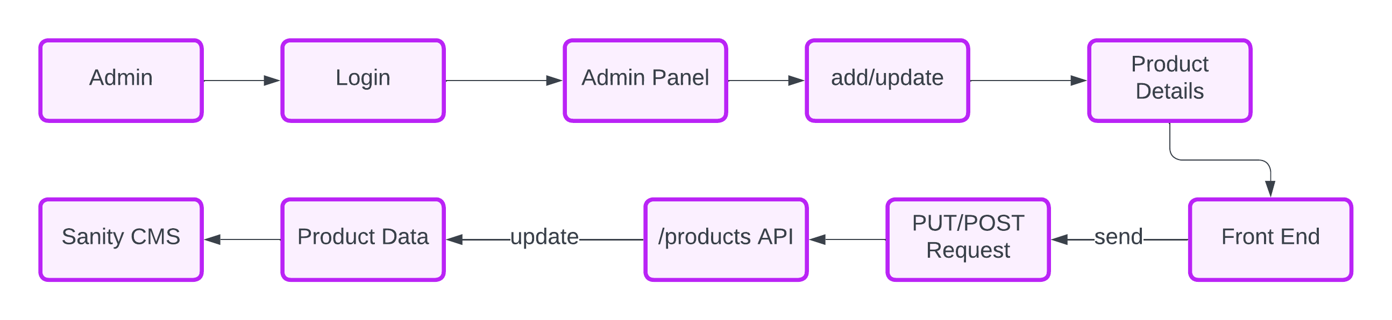

#### **Monitoring Orders and Rentals**:

1. *Admin views order or rental data.*
2. *Frontend sends GET requests to /orders or /rental.*
3. 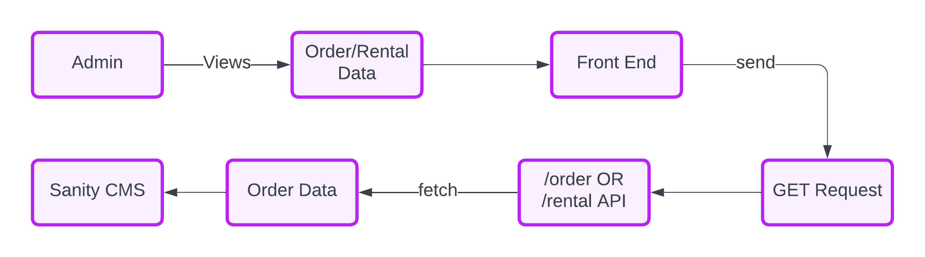*API retrieves data from Sanity CMS for admin action.*

## 3. **Category-Specific Instructions**

### ****Rental E-Commerce:****

* Include workflows for rental duration and deposit management.
* **Example schema field:**
  + Rental Duration: Specifies the rental period (e.g., "7 days").
  + Deposit Amount: Stores the refundable deposit.
  + Condition Status: Tracks the condition of returned items.

### ****General E-Commerce****

* Focus on product browsing, cart management, and order placement workflows.
* Example endpoint: /products to fetch available items.

## **4. API Endpoints**

|  |  |  |  |  |
| --- | --- | --- | --- | --- |
| Endpoint | Method | Purpose | Payload | Response Example |
| /products | GET | Fetches all product details | None | { "id": 1, "name": "Table", "price": 500 } |
| /orders | POST | Creates a new order | { "userId": 123, "items": [{...}] } | { "orderId": 456, "status": "Success" } |
| /rental | POST | Adds rental details | { "productId": 789, "duration": "7" } | { "confirmationId": 321, "status": "Confirmed" } |
| /shipment | GET | Fetches shipment tracking data | { "orderId": 456 } | { "status": "In Transit", "ETA": "2 days" } |

## **5. Sanity Schema Example**

## **6. Technical Roadmap**

**Technical Roadmap for Furniture Marketplace**

### ****Week 1: Planning & Design****

* **Deliverables:**
  + Finalize business requirements and technical specifications.
  + Design wireframes and UI/UX for:
    - Homepage
    - Product listing and details pages
    - Cart and checkout
    - Rental management
    - Admin dashboard
  + Create a detailed **System Architecture Diagram**:
    - Frontend (Next.js)
    - Backend (Node.js with APIs)
    - Sanity CMS integration
    - ShipEngine for shipment tracking.
  + Plan database schemas for:
    - Products, rentals, orders, users, and shipment tracking.

### ****Week 2: Frontend Development - Core UI****

* **Deliverables:**
  + Build responsive UI components using **Next.js** and **Tailwind CSS**:
    - Homepage: Showcase featured furniture and categories.
    - Product Pages:
      * General product details.
      * Rental-specific information (e.g., rental duration, deposit).
    - Cart and Checkout:
      * Enable add-to-cart, rental duration selection, and checkout flows.
    - Order Tracking Page:
      * Display real-time tracking status (integrated with ShipEngine).
  + Implement **React Context API** or **Zustand** for state management.
  + Integrate **React Hook Form + Zod** for input validation in forms.

### ****Week 3: Backend Development - API & CMS****

* **Deliverables:**
  + Develop backend API:
    - /products: Fetch product and rental information.
    - /orders: Create and manage orders.
    - /rental: Handle rental-specific data like duration, deposits, and condition tracking.
    - /shipment: Integrate ShipEngine for order tracking.
  + Integrate **Sanity CMS**:
    - Set up schemas for products, orders, rentals, and tracking details.
    - Build APIs to fetch/update CMS data.
  + Implement authentication (e.g., Firebase or Clerk):
    - User login/signup for customers.
    - Admin authentication for product/order management.

### ****Week 4: Integration - Frontend with Backend****

* **Deliverables:**
  + Connect frontend UI components to backend APIs:
    - Product listing page fetches data from /products.
    - Cart and checkout send order data to /orders.
    - Order tracking page fetches data from /shipment.
  + Add error handling and loading states for APIs.
  + Test rental-specific flows:
    - Verify deposit and duration handling.

### ****Week 5: Shipment & Order Tracking****

* **Deliverables:**
  + Integrate **ShipEngine API**:
    - Configure API to create shipment labels and retrieve tracking information.
    - Add /shipment endpoint to backend for:
      * Tracking shipment status (e.g., "In Transit," "Delivered").
      * Estimating delivery time.
  + Display real-time tracking updates on the **Order Tracking Page**.
  + Implement email notifications:
    - Send order confirmation and shipment updates to users.

### ****Week 6: Admin Panel Development****

* **Deliverables:**
  + Build a responsive admin panel using Next.js:
    - Product Management: Add/edit/delete products.
    - Order Management: View and update order statuses.
    - Rental Management: Monitor rental returns and condition tracking.
  + Integrate analytics for admin dashboard:
    - View sales data, rental trends, and user activity.

### ****Week 7: Testing & Optimization****

* **Deliverables:**
  + Conduct end-to-end testing:
    - Verify UI flows for both general purchases and rentals.
    - Ensure accurate shipment tracking and order updates.
  + Optimize API performance:
    - Add caching for frequently accessed data (e.g., products).
  + Test for scalability:
    - Simulate high traffic for product and order APIs.
  + Fix UI/UX bugs identified during testing.

### ****Week 8: Deployment & Launch****

* **Deliverables:**
  + Deploy frontend and backend:
    - Use **Vercel** for Next.js frontend.
    - Use **Sanity CMS** as backend.
  + Set up CI/CD pipelines for seamless updates.?
  + Launch the platform:
    - Announce the launch and onboard initial users.

### ****Post-Launch Maintenance****

* Monitor system performance and fix bugs.
* Roll out enhancements:
  + Add advanced filters and sorting options.
  + Introduce loyalty programs or subscription models for frequent renters.